**DDS DS 6306 Project 2: Crab Age**

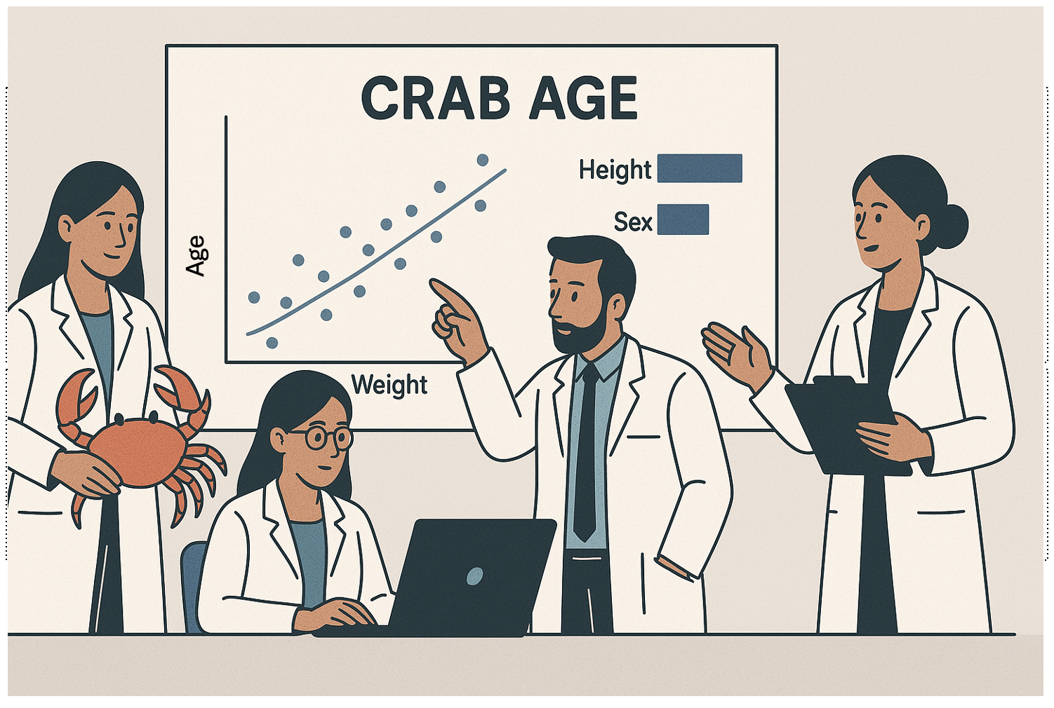

**Introduction**

Wine quality is a multifaceted attribute influenced by a myriad of factors, including chemical properties, production techniques, and environmental conditions. The goal of this data science project is twofold:

1. **Objective A**: Your task is to use regression to predict the age of crabs given physical attributes. Good luck!
2. **Objective B**: Analyze the data to uncover key factors or relationships that contribute to predicting the age of crabs. Any other interesting or useful discovered relationships will be value as well!

**Objective A: Building a Predictive Model**

The primary objective is to develop a robust predictive model that accurately predicts crab age based on various features. We aim to achieve the lowest possible Mean Absolute Error (MAE) on the test set, ensuring high precision in our predictions.

**Mean Absolute Error (MAE)** is a commonly used metric for evaluating regression models. It measures the average magnitude of errors in a set of predictions, without considering their direction. The formula for MAE is:

Minimizing MAE ensures that our model predictions are as close as possible to the actual values, providing a reliable tool for assessing wine quality.

The student with the lowest MAE on the test set will win an extra 5 points on the project and Bragging Rights! ☺

**Objective B: Mining Data for Insights**

Beyond prediction, this project aims to delve into the dataset to identify the key determinants of crab age. By analyzing the relationships between various crab metrics and age, we can provide valuable insights to help scientists understand their growth rate, reproductive cycles, and lifespan which can help commercial markets as well as scientific studied into climate change, effects of ocean pollution, shifts in predatory trends, etc.

**Feature Details:**

Input variables:

|  |
| --- |
| Sex |
| Length |
| Diameter |
| Height |
| Weight |
| Shucked Weight |
| Viscera Weight |
| Shell Weight |
|  |

Output variable (based on sensory data):

Age

**Dates:**

Final Project Deadline: Sunday, April 21st at 11:59pm CST

**Deliverables:**

7 min recorded group presentation with the link posted on this Google Doc:

<https://docs.google.com/document/d/1rTSFZJa8RA4H7wCYanFYfO_bLDQOimvGxMOUdZs7L2M/edit?usp=sharing>

Predicted ages of crabs for the competition set. This should be in CSV format and should have two columns: ID and age.

RShiny Dashboard that at least shows the predicted quality of a wine given certain specs.

Rmarkdown that describes your analysis.

GitHub Repo with all files that pertain to the deliverables above.

Groups:

|  |
| --- |
| **Group 1** |
| Barker, Chloe |
| Nunnally, Drew |
|  |
| **Group 2** |
| Dower, Tracy |
| Camara, Sumtana |
|  |
| **Group 3** |
| Davisson, Kyle |
| Rocha, Jonathan |
|  |
| **Group 4** |
| Karuri, Titus |
| Streeter, Devin |
|  |
| **Group 5** |
| Vogt, Johnny |
| Flores, Michael |

Please reach out to your partner via email asap to establish the lines of communication. ☺